# A Definitive Guide to Generative AI with Amazon Bedrock

# Chapter 6: Overview of Retrieval-Augmented Generation (RAG)

# In the rapidly changing world of generative AI today, it is essential to be able to come up with answers that are accurate and relevant to the situation. But as these models have become more complicated, a major flaw has shown itself: they can't use outside information sources to make their results better and more factual.

# In this case, retrieval-augmented generation (RAG) is very important. The RAG method is very effective because it combines the best parts of large language models with the power of information retrieval systems to find knowledge. By blending these two parts together smoothly, RAG models can dynamically access important external information during the generation process. This makes the text clear and logically generated output and also based on facts and more reliable.

# In this part, you will learn about RAG's main ideas and build patterns. Additionally, you will discover its practical applications, and the challenges encountered during implementation. First, you will look at the retrieval models that RAG is based on and talk about why this method is so useful for many different natural language processing tasks.

# After that, you'll look more closely at the RAG design, checking out the part that embeddings play and how language models and knowledge retrieval systems can work together. You will also learn about LangChain, a powerful system that makes it easier to build RAG-based apps.

# As an example of how RAG can be used in real life, you will build a simple Streamlit app to show how this technology can be used to make smart, knowledge-driven user experiences. Lastly, you'll look at some advanced RAG design patterns and understand the most important things to keep in mind when working with this approach.

# You will fully grasp Retrieval-Augmented Generation, its basic ideas, and the useful tools and methods you can use to include this strong method in your own natural language processing tasks by the end of this chapter.

# 6.1 Introduction to RAG

# Imagine a fictitious insurance company, AnySecureLife, had trouble providing personalized insurance plans because agents didn't have enough capability to navigate customer detail information from enterprise. Emma, a possible buyer, came up to them one day looking for health insurance. AnySecureLife had created a way to write policies leveraging the Large Language Model (LLM), but it didn't have up-to-date information on Emma's health history or financial situation. This limitation resulted in generic and often inaccurate suggestions.

# To address this issue, AnySecureLife’s product team devised a strategy to integrate real-time retrieval from health databases and financial records. By doing so, they generated a customized and accurate policy for Emma. By taking this new method, they were able to change what they were selling and make sure that every customer got well-informed, custom insurance solutions. Here's an example. This approach could be a design pattern that is used in many different industries.

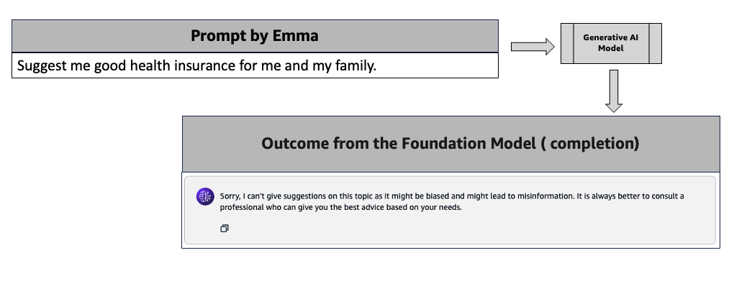

Figure 6.1 Example of basic prompt about health insurance. Output generated by Amazon Titan model at Amazon Bedrock.

RAG enhances the results of a large language model by using an external, proprietary knowledge base in addition to its original training data to come up with more accurate and well-thought-out answers. Large language models (LLMs) are trained on vast amounts of data and use billions of factors to come up with new answers to questions, translate languages, and finish sentences.

RAG uses the power of LLM and adds the organization's own information base to make the context better. That too without having to train the model again. This is a cost-effective way to make sure that LLM output stays current, correct, and useful in different situations.

In 2020, Patrick Lewis and his co-authors came up with the idea of retrieval-augmented generation (RAG). It has been used as a design pattern in a huge number of other study papers and business services since then (https://arxiv.org/pdf/2005.11401). The RAG project is a big step forward in generative AI, even though the name was made by accident. A lot of language models are more accurate and effective when they use real-world sources.

RAG addresses a fundamental limitation of large language models (LLMs). Traditional LLMs, built on neural networks with billions of parameters, excel at generating text based on generalized patterns in human language. However, they often struggle to give detailed and current information on specific topics.

# RAG connects LLMs with more resources that have the most up-to-date technical knowledge to deal with this problem. This "general-purpose fine-tuning recipe" which was made with help from researchers at Facebook AI Research, University College London, and New York University, lets any LLM connect to various outside knowledge bases. This method makes it much easier for the model to come up with correct and useful answers. It is a major step forward in the development of generative AI.

# 6.2 Understanding Retrieval Models

Retrieval models play an important role in enhancing the functionality of information retrieval systems. This section will provide you with an overview of retrieval models. The idea is to fetch valuable data from various sources to assist programs such as virtual assistants. These architecture patterns help locate and retrieve relevant information quickly for user queries.

AnyTripGenius, a fictional app, is an online travel company for trip planning. AnyTripGenius uses a retrieval model to look through huge databases of travel guides, reviews, and user-generated content to find suggestions for holiday spots. For instance, when you inquire about "family-friendly vacation destinations in Singapore," the retrieval model scans its database to identify items that correspond to the query's context.

The retrieved outcomes provide personalized and accurate suggestions. For example, the system recommends the Singapore Zoo or Universal Studios Singapore based on the user's preferences and current travel trends.

Retrieval models use algorithms to rank and retrieve information. They consider factors like relevance, recency, and user intent. These models enhance accuracy and relevance by using advanced search techniques and a broad knowledge base. They are important for generative AI design patterns.

# 6.3 Why Retrieval-Augmented Generation

Imagine an LLM as an over-enthusiastic “know-it-all” friend who confidently answers every question but refuses to stay informed with current events. Such behavior can negatively impact user trust, which is undesirable for the customer or user.

RAG addresses these challenges by redirecting LLMs to retrieve relevant information from proprietary, predetermined knowledge sources. This approach allows organizations to have greater confidence in the context-aware generated output. It also aids in understanding the lifecycle of the prompt flow, and LLM provides the necessary answers.

**Affordable Implementation**: Generative AI-powered solution development typically begins with foundation models (FMs). These LLMs, accessible through APIs, acquired their knowledge from vast quantities of generalized data. Retraining these models for organizational or domain-specific information is expensive. RAG is a cost-effective method because it adds new data to the LLM without requiring training all over again. The result makes generative AI technologies more adaptable.

**Access to Up-to-Date Information**: It's challenging to keep static training data relevant. RAG enables developers to directly link generative models to frequently updated sources of information, such as live social media feeds, news sites, and enterprise data. So, developers can provide enhanced context to the generative AI models with the latest research, current data, or news. This ensures that the LLM can provide users with the most current information.

**Reduced hallucinations**: According to research, RAG models tend to produce fewer hallucinations and more accurate responses. They are also less prone to leaking sensitive information, making them a more trustworthy option for content generation. This depends on the use cases and the intended purpose of the solutions.

**Increased User Trust**: RAG allows users to present generated output with source attribution, increasing user trust. You can build system including citations or references to sources along with the generated output. This transparency increases trust and confidence in the generative AI solution.

**Flexible Developer Control**: RAG makes it simple for developers to test and improve their generative AI-powered solution. They can easily change the information sources to adapt evolving requirements and cross-functional use cases. They can troubleshoot issues when the LLM cites inaccurate information sources. This includes restricting sensitive information retrieval to align with appropriate authorization levels and ensuring appropriate responses.

**Better LLM Memory**: Traditional LLMs use "parametric memory." RAG improves on this by increasing memory capacity. It enhances the LLMs' knowledge base for better responses. RAG also introduces "non-parametric memory" with external knowledge sources.

**Enhanced Context Awareness**: RAG improves the way LLMs understand context by retrieving and incorporating relevant documents and enhancing the context.

**Updatable Memory**: RAG allows for real-time updates and refresh sources without extensive model retraining. Developers update the external knowledge base, ensuring LLM-generated replies are based on it.

**Citations for sources**: RAG design patterns make things more trustworthy by showing where the answers came from. You can view the data the LLM uses for answers. This increases trust in the generated responses.

Together, these advantages make RAG a game-changing framework in natural language processing. It addresses the shortcomings of traditional language models and boosts the potential of AI-driven applications.

# 6.4 RAG Architecture

You will gain a detailed understanding of the RAG architecture in the following sections (Figure 6.2).

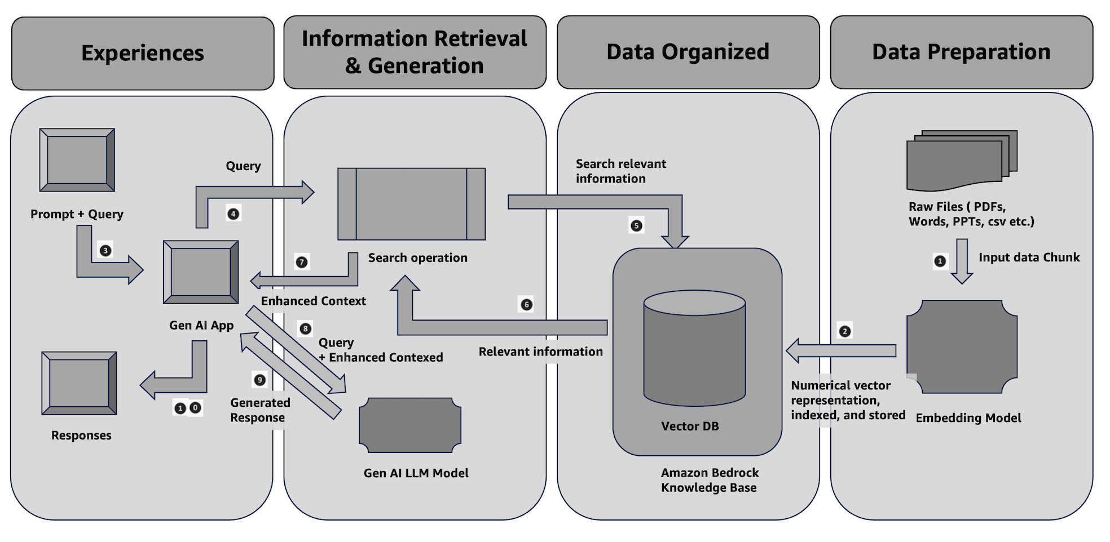

Figure 6.1 RAG Architecture Block Diagram

**Data preparation and organization**

1. The selected embedding model requires the chunking of documents into appropriate lengths. The text embedding component converts the input text, whether it's a document or other textual data, into a numerical vector representation. An embedded LLM is required to perform this task. This is a continuous process for more documents or updates to existing ones.
2. This vector preserves the semantic and linguistic relationships between words or phrases referred to as chunk vectors. This enables the system to understand the meaning and context of the input rather than simply treating it as a sequence of characters.

The Vector DB helps retrieve and process information efficiently. It stores vector representations, or embeddings, of text chunks or documents created by the text embedding component.  
  
It produces document embeddings and populates a Vector Search index with this data.

**Experiences, information retrieval, and generation**

1. The generative AI-powered application receives the prompt and the query.
2. The query initiates a search operation. The query transforms into an embedded vector.
3. The model then uses the query vector to search a vector database, which has precomputed vectors representing potential contexts from which it can generate a response.
4. The system retrieves the most relevant contexts based on how closely their vectors match the query vector.
5. The search operation returns the enhanced context to the generative AI-powered application.
6. The application sends the prompt, query, and enhanced context to the generative AI model to generate a response.
7. The generative AI-powered application receives the generated responses.
8. The user can then interact with and experience the responses.

# 6.5 Overview of Embeddings

In the context of RAG, embeddings play an important role in connecting large language models (LLMs) with external knowledge sources. So, embeddings help bridge the gap between the retrieval and generation phases.

Embeddings are numerical representations of text (or other data types) that capture the meaning or semantic relationships between words, phrases, or documents. High-dimensional vectors usually represent these. Similar texts are closer in the vector space. The aim of embeddings is to convert unstructured data into a format suitable for machine learning models.

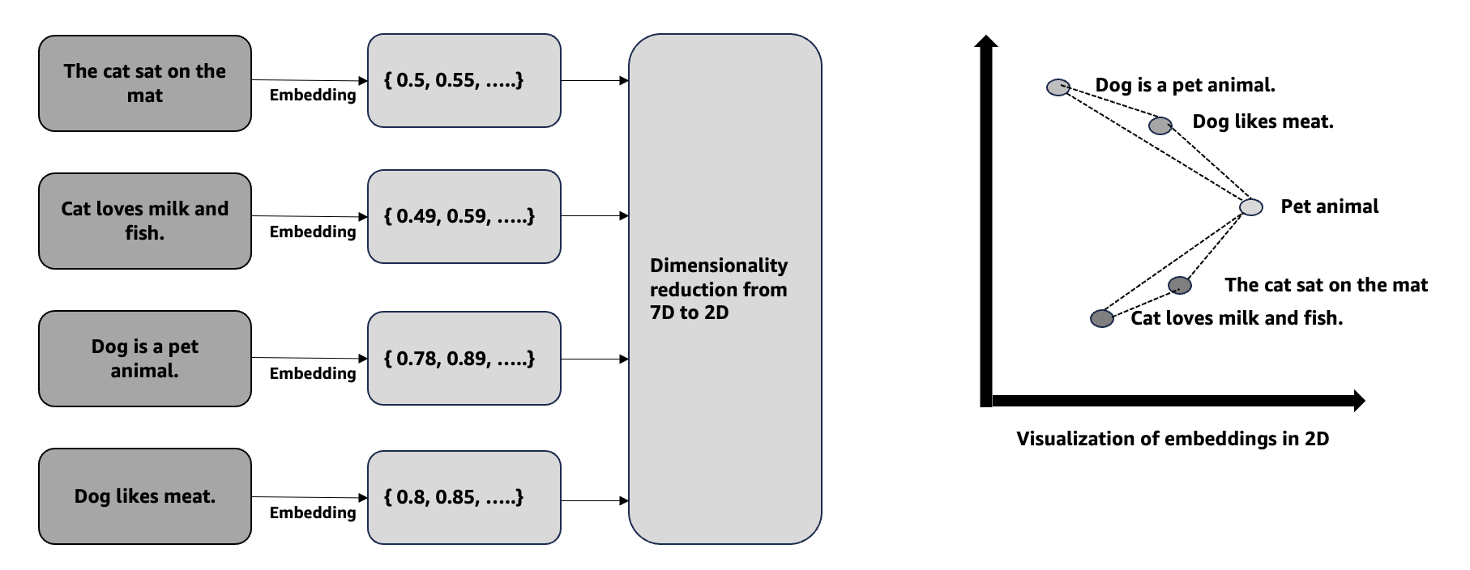

Figure 6.3 Embeddings vector from sentences (This is for illustration purposes)

There are a variety of objects that need to be embedded for different use cases. You will mostly learn documents embedded throughout this book. You will learn image embedding in Chapter 19 of this book.

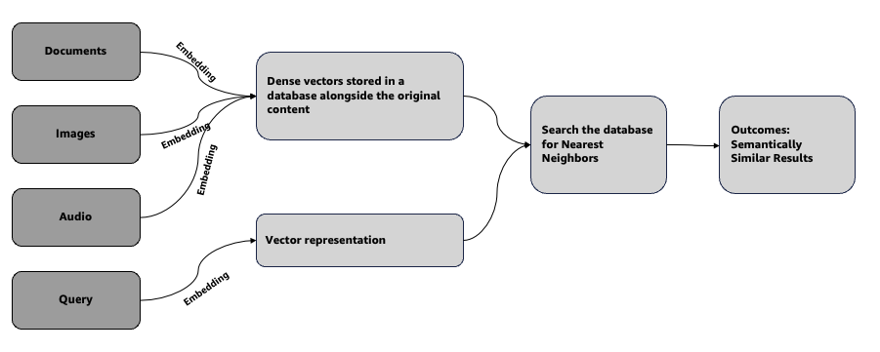

Figure 6.4 Flowchart of how embeddings work

Let's first explore the role of embeddings in RAG. These are four important steps.

Generating a response

Retrieving the context

Embedding the query

Embedding the context

Each document or knowledge snippet in the database has its own precomputed embedding. These embeddings represent the semantic content of the information, enabling efficient and meaningful retrieval.

When a user submits a prompt, the first step is to convert this query into an embedding—a fixed-size vector that encapsulates the query's meaning.

The generated query embedding is used to search through a vector database. This database has precomputed embeddings of documents or knowledge snippets. The search finds the most relevant contexts by locating embeddings that are closest to the query embedding.

The RAG system retrieves the top-matching contexts based on their embeddings and combines them with the query. This combined data (query and relevant contexts) is fed into a Generative AI model to produce a coherent and contextually accurate response.

Table 6.1 Role of embeddings in RAG

Let's understand this concept with an example. Imagine you are an insurer agent of an insurance company. You ask a query, “What are the best insurance products of my company?”

Generating the final response

Creating the query embedding

Finding relevant information

Providing context to the generative AI model

The retrieved documents containing similar context like "Life insurance has higher revenue than" are identified. They are then sent with the original query to the generative AI model. The model uses this context to create a precise and relevant response.

An embedding model transform the prompt "What is the best insurance products offering for customer?" into a vector representation. This vector captures the semantics of the query, including the understanding that it is asking for an insurance product.

The final output from the generative model might be:

"Life insurance product suites are more effective in terms of revenue generation for the insurance company.”

The query embedding is then used to search a vector database containing embeddings of various documents or knowledge. The vector database has facts about various insurance products, including rules and eligibility. The system measures similarity between the query and document embeddings. Documents about "Life insurance" or "Home insurance" will closely match the query embedding, leading to their retrieval.

Table 6.2 Role of embeddings in RAG – An example

Let's understand this concept in generic terms with three steps below.

Ensuring contextual relevance

Scalability

Efficient searching

Embedding-based search scales well with large datasets, making RAG suitable for complex, multi-domain applications.

By retrieving semantically related documents, embeddings ensure that the generative model has the right context to generate more meaningful and coherent responses.

Embeddings allow the system to search for information based on meaning rather than keywords, making retrieval more efficient and accurate.

Table 6.3 Benefits of Embeddings in RAG

# In summary, embeddings are the backbone of the retrieval process in RAG. This process transforms text into a machine-understandable format. It also enables the integration of external knowledge into the generative AI workflow. **Quality of Training Data**: Embeddings perform effectively with high-quality training data. **Managing high-dimensional space**: High-dimensional vector spaces are resource-intensive. They need significant time and resources, particularly with large datasets. **Avoiding Information Loss**: Although embeddings condense data into a manageable form, this process can sometimes strip away subtle details, leading to the underrepresentation of important nuances. **Addressing Interpretability Issues**: Embeddings can be hard to grasp, especially for non-experts in machine learning. This lack of clarity can be an issue in fields where knowing how AI makes decisions is important. **Balancing generalization with specificity**: Striking the right balance between creating embeddings that are broad enough to be widely applicable yet specific enough to be useful for purpose-built tasks can be challenging. Understanding these challenges is essential for effectively implementing vector embeddings, enabling informed decisions, and anticipating potential obstacles.

# 6.6 Overview of LangChain

LangChain is an open-source framework designed to help developers build applications powered by large language models (LLMs). (https://python.langchain.com/v0.2/docs/introduction/) LangChain offers a suite of tools and abstractions that enhance the customization, accuracy, and relevance of the information produced by these models. For example, developers can use LangChain to create or adjust prompt chains. LangChain also offers components for LLMs to access fresh data without retraining. This keeps the generative AI application current and effective.  
  
To illustrate, imagine you are building a customer service chatbot. LangChain allows you to build the chatbot with customize LLM prompts to make more flexible. It also enables the integration of new data sources for accurate and current information through chatbot.  
  
LangChain is crucial because it bridges the gap between large language models (LLMs) and the specific needs of organizations. LLMs excel at answering general questions. However, they have difficulty with specific domain queries. For example, an LLM may provide a broad approximation of health insurance costs. However, it would not be accurate of delivering the precise cost of a certain health insurance package offered by your organization.  
  
You must integrate the LLM with internal data for specificity. You also need to design prompts carefully. This process involves refining inputs to ensure the model produces context-specific outputs.  
  
LangChain simplifies the process of creating these data-responsive applications, making prompt engineering more efficient. It's designed to help developers build a wide range of applications powered by LLMs, such as chatbots, question-answering systems, content generators, summarizers, and more.

Let’s understand the benefits of LangChain below.

Table 6.4 Benefits of LangChain

There are three main properties of LangChain though you will learn most of the below components throughout this book with some examples.

Table 6.5 Properties of LangChain

You will learn most of this concept on section 6.8

# 6.7 Overview of a Simple Streamlit Application

Streamlit is a powerful and easy-to-use framework for creating interactive web applications with Python. It enables you to swiftly transform your data scripts into shareable web applications without the need for advanced web development skills. You will learn to create some basic Streamlit applications in the rest of the book. [(https://streamlit.io/](https://streamlit.io/))

# 6.8 A Sample Application Building with RAG

To get the GitLab details, refer to the **appendix** section of this book. In GitLab, locate the repository named **genai-bedrock-book-samples** and click on it.

Inside the **genai-bedrock-book-samples** repository is an AWS CloudFormation template that resides in the **cloudformation** folder. If you already executed the AWS CloudFormation template in Chapter 3 and didn't delete the stack afterward, you can skip the paragraph highlighted in grey below.

The task requires the execution of an AWS CloudFormation template, which should be performed once for all exercises in this book. A detailed guidance on how to manually execute the AWS CloudFormation template can be found in a file called **README** located within a directory named **cloudformation**. For more information about AWS CloudFormation template refer <https://aws.amazon.com/cloudformation/>.

***Disclaimer****: It is advisable to delete the AWS CloudFormation template if you are not actively participating in any exercises for some longer duration. Clear instructions for deleting the AWS CloudFormation template are provided within the README file itself.*

However, in the **genai-bedrock-book-samples** folder there’s another subfolder titled **chapter6**. The **README** file within **chapter6** folder provides clear instructions on launching a **Notebook** on Amazon SageMaker.

|  |  |
| --- | --- |
| File Name | File Description |
| simple_rag_building_langchain.ipynb | 1. Create an open-source Chroma vector store.  2. Ingest data into the Vector DB.  3. Retrieve data with langchain framework  **Dependency**: simple-sagemaker-bedrock.ipynb at Chapter 3 should work properly. |
| simple_rag_building_llama_index.ipynb | 1. Ingest data into the Vector DB.  2. Retrieve data with langchain framework  **Dependency**: simple-sagemaker-bedrock.ipynb at Chapter 3 should work properly. |
| advanced_rag_building.ipynb | 1. Advanced rag use cases  **Dependency**: simple_rag_building_langchain.ipynb and simple_rag_building_llama_index.ipynb at Chapter 6 should executed properly. |

# 3.8 Bedrock Interaction Sample Application

***Disclaimer****: Charges will apply upon executing above files. Therefore, it is important not to forget to clean up the kernel after studying the topic. Refer to the clean-up section for instructions on how to properly clean up the kernel.*

# 6.9 Challenges & Considerations

# Implementing retrieval-augmented generation (RAG) involves several challenges. It is important to address these challenges for successful deployment. The aim is to develop a RAG system that fulfills technical requirements. Additionally, the system should adapt to changing needs. It must also ensure trustworthiness.

# **Choosing the right chunk size and strategy**: This is important in RAG. The chunk size affects the retrieval model's performance and the accuracy of generated content. If a chunk is too large, it may contain irrelevant data, reducing the value of the information retrieved. On the other hand, if a chunk is too small, it may lack context, resulting in incomplete or unclear responses. For instance, a legal firm using AWS Bedrock for contract analysis might face issues. Small chunks could cause the retrieval model to miss important context, like the relationship between clauses. Large chunks may contain irrelevant sections. This includes boilerplate text. Such content can confuse the generation model.

# **Building a strong and scalable pipeline**: This is also important for RAG implementation. It should efficiently handle data ingestion, processing, retrieval, and generation. AWS Bedrock provides strong tools for integration. Careful planning is needed for data flow, parallel processing, and failure management. A global e-commerce platform requires a solid RAG pipeline for real-time product recommendations. This pipeline must handle large data volumes and quickly access relevant product information. It must handle occasional retrieval failures.

# **Ensuring retrieved data is contextual and trustworthy**: A significant challenge in RAG systems is ensuring that the retrieved data is presented in the right context, maintaining the interpretability and trustworthiness of the generated output. Without the correct context, the user might question the validity of the information. For instance, if we take the retrieved medical records out of context in a healthcare setting, using RAG to assist in diagnosing conditions could lead to dangerous misinterpretations. For example, a symptom mentioned in a different context could be mistakenly attributed to the wrong condition.

# **Task-based retrieval**: This needs customization for each specific task or query. This can be difficult in changing environments. AWS Bedrock's adaptability to different tasks requires careful tuning. This tuning helps align the retrieval process with the task's goals. For instance, an automated customer support system handles various queries. Technical troubleshooting and account management queries need different retrieval methods. It's crucial to optimize the RAG system to identify these tasks. This ensures the retrieval of accurate and relevant information.

# **Optimizing the vector database for accurate document retrieval**: Optimizing the vector database is essential for accurate document retrieval. The efficiency of a RAG system relies on this optimization. It indexes and retrieves relevant chunks of data. Proper tuning is crucial for search accuracy and performance. This is especially important with large data sets. For example, a financial institution retrieving regulatory documents from AWS Bedrock must fine-tune the vector database. They need to prioritize the most recent and relevant regulations. Any oversight could lead to outdated or irrelevant compliance information.

# **Avoiding retrieval of outdated content**: Retrieving outdated content is a major challenge in fast-evolving fields. It can mislead users. The RAG system should focus on the latest data. It must filter out old information. For instance, a tech firm using RAG for software documentation may encounter problems if outdated API references are retrieved. This can mislead developers. Regular updates are essential. A strategy for managing outdated content is also necessary. This ensures the information remains accurate and relevant.

# **Optimizing response times for users**: User experience in a RAG system heavily relies on response time. Slow retrieval or generation processes can frustrate users and hinder adoption. Optimizing the entire pipeline for speed while maintaining accuracy is a delicate balance. For example, in a live chatbot system, users expect near-instant responses. Users may abandon the interaction before receiving the necessary information if AWS Bedrock's RAG model does not optimize for response time, thereby negatively impacting the overall user experience.

# **Managing inference costs**: Managing inference costs is important when running RAG models. These models can be expensive, especially with large datasets or frequent queries. It's crucial to balance accuracy and cost-effectiveness. For instance, a large media company may use RAG for personalizing content for millions of users. We need to manage the inference costs on AWS Bedrock carefully. This will help avoid unsustainable expenses and ensure efficient content delivery.

# **Maintaining data security**: Maintaining data security is crucial with sensitive data in RAG systems. AWS Bedrock has strong security features. However, additional measures like encryption, access control, and regular audits are necessary. For example, a government agency must control access and encrypt data when retrieving classified information. A breach could lead to serious legal and operational issues.

# **Supporting continuous learning and adaptation**: Supporting continuous learning and adaptation is essential for RAG systems. They must learn and adapt to new data and changing user needs. This involves updating the model, retraining with new data, and fine-tuning retrieval methods. For instance, a news organization using RAG for content must regularly update the system with the latest news. AWS Bedrock supports this by allowing continuous model updates, keeping the content relevant and accurate.

# 6.10 Advanced RAG Design Patterns

This section presents various RAG design patterns. These patterns are designed for different use cases. You will examine them at a high level. Each pattern has its own use cases, benefits, and limitations.

**Fundamental RAG**: Fundamental RAG is sometimes called Naive RAG. This pattern represents the most straightforward approach to retrieval-augmented generation. You are already familiar with this RAG pattern from all the previous sections (Figure 6.1). In this setup, a retrieval system receives a user query and retrieves relevant documents from a database. The retrieval system then passes these documents to a large language model (LLM) to generate a response.

You will learn the benefits of this RAG pattern below.

Table 6.6 Benefits of Fundamental RAG

Some of the potential limitations of this RAG pattern are explained below.

Table 6.7 Limitation of Fundamental RAG

**HyDE RAG:** The Hypothetical Document Embedding (HyDE) pattern is a new approach in Retrieval-Augmented Generation (RAG). It enhances the retrieval process with a Large Language Model (LLM). Instead of retrieving documents directly from the original query, HyDE generates a hypothetical answer first. This answer is then embedded into a vector space. The vector is used for retrieval. This method aligns the retrieval process with the query's intent. It may result in more accurate and relevant outcomes. ( https://arxiv.org/pdf/2212.10496.pdf)

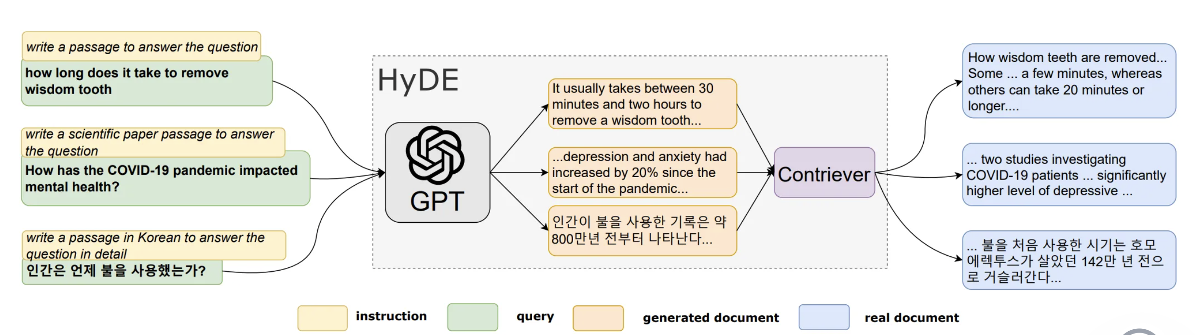

Figure 6.5 HyDE RAG Pattern (sources: https://arxiv.org/pdf/2212.10496.pdf)

You will learn the benefits of this RAG pattern below.

Table 6.8 Benefits of HyDE RAG

Some of the potential limitations of this RAG pattern are explained below.

Table 6.9 Limitation of HyDE RAG

**Multi-query RAG**: Multi-query RAG improves traditional RAG. It expands one user query into several similar queries. Each query retrieves relevant documents from a knowledge base. The retrieved documents are then reranked. The most relevant documents are used to generate the final response. This method enhances the relevance and accuracy of the output. ( <https://arxiv.org/abs/2402.03367>)

Figure 6.6 Multi query RAG Pattern

Reciprocal rank fusion (RRF) is a key algorithm in multi-query RAG patterns. It assigns scores to retrieved documents based on their rank. Then, it reranks the documents accordingly. To calculate the RRF score, use this formula.

**rrfscore = 1 / (rank + k)**

"Rank" indicates the document's current position in a sorted list. This list is based on relevance. "K" is a constant smoothing factor. It modifies the impact of the existing ranks.

When this reranking process is applied within the context of RAG, the technique is known as RAG-Fusion. RAG-Fusion effectively combines the strengths of multiple retrievals, leading to more accurate and contextually appropriate responses. This method is particularly valuable in situations where precision is critical, such as legal document analysis or complex research tasks.

You will learn the benefits of this RAG pattern below.

Table 6.10 Benefits of Multi-query RAG

Some of the potential limitations of this RAG pattern are explained below.

Table 6.11 Limitation of Multi-query RAG

**Sentence Window Retrieval RAG:** This RAG pattern focuses on individual sentences for retrieval. This method optimizes information retrieval. The system pulls in relevant information, often just a sentence or two. It avoids using entire documents or paragraphs. This provides the language model (LLM) with targeted data. The generated content is more precise and contextually accurate. Enhanced precision is achieved by retrieving at the sentence level. This reduces noise from larger text blocks. The LLM can focus on the most pertinent details.

Figure 6.7 Sentence window Retrieval RAG Pattern

You will learn the benefits of this RAG pattern below.

Table 6.12 Benefits of Sentence Window Retrieval RAG

Some of the potential limitations of this RAG pattern are explained below.

### Table 6.13 Limitation of Sentence Window Retrieval RAG

### **Document Summary Index RAG:** The Document Summary Index RAG pattern is a powerful technique designed to enhance both the speed and accuracy of information retrieval in large-scale systems. Here’s a look at how it works, along with its benefits and limitations.

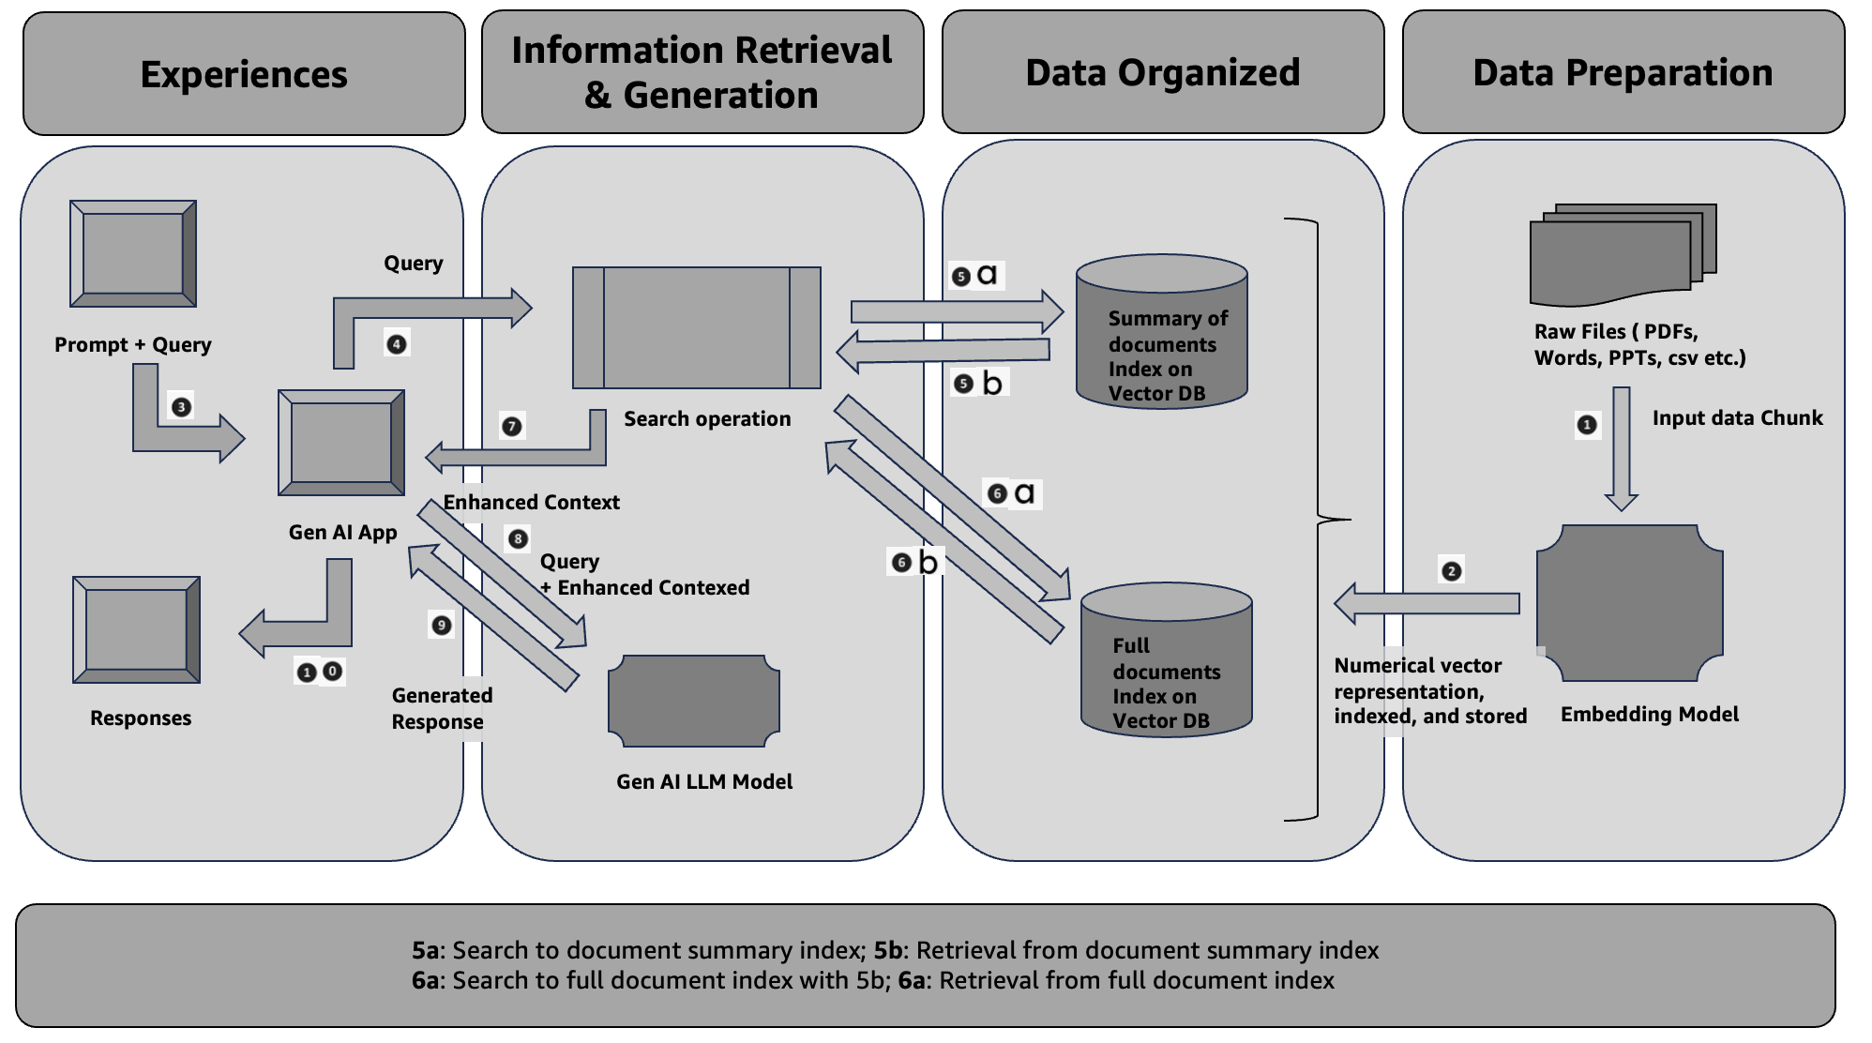

*Figure 6.7 Document Summary Index RAG Pattern*

The Document Summary Index method involves creating an index of document summaries rather than the full documents. When a query is made, the system quickly retrieves relevant summaries from this index. However, for generating responses, the system accesses the full text of the documents. This approach ensures that retrieval is both fast and efficient while allowing the generation of detailed, accurate responses based on the full content. Refer 5a, 5b, 6a, 6b flow on Figure 6.7.

You will learn the benefits of this RAG pattern below.

Some of the potential limitations of this RAG pattern are explained below.

### **Reranker RAG:** Reranker RAG Patterns are a sophisticated approach within Retrieval-Augmented Generation (RAG) pipelines that add an additional layer of refinement to the retrieval process. These patterns involve a reranking step, where documents initially retrieved are reassessed and reordered based on their relevance to the query. This step uses various techniques, such as Maximal Marginal Relevance (MMR), Cohere reranker, or LLM-based rerankers.

**Benefits:**

1. **Enhanced Relevance**: By applying a reranking step, the system improves the relevance of the documents presented in the final output. For instance, MMR helps balance between relevance and diversity, ensuring that the results are both pertinent and varied.
2. **Improved Accuracy**: Rerankers refine the results based on a deeper understanding of the query, leading to more accurate and contextually appropriate responses. This is particularly beneficial in complex queries where initial retrieval might miss nuanced details.
3. **Dynamic Adaptability**: Techniques like LLM-based rerankers can adapt to different types of queries and contexts, making them versatile for various applications. This flexibility ensures that the system remains effective across diverse use cases.
4. **Reduced Noise**: By filtering out less relevant documents in the reranking phase, these patterns help reduce noise and focus on high-quality content, enhancing the overall user experience.

**Limitations:**

1. **Increased Complexity**: Adding a reranking step introduces additional complexity to the RAG pipeline. This can require more computational resources and time, potentially impacting performance, especially in real-time systems.
2. **Potential Overhead**: Implementing sophisticated reranking techniques like LLM-based models might involve significant overhead in terms of both processing power and development effort. This might present a challenge in environments with limited resources.
3. **Dependence on Initial Retrieval Quality**: The effectiveness of the reranking step heavily depends on the quality of the documents retrieved initially. If the initial retrieval process is flawed, reranking may not fully resolve the issues.
4. **Algorithmic Limitations**: Techniques like MMR and Cohere rerankers have their own limitations and might not always align perfectly with the nuances of every query, potentially leading to suboptimal reranking results.

**Example Implementation:**

For a practical example of how to incorporate a reranking step using LangChain, you can refer to this guide: [LangChain Reranker Example](https://python.langchain.com/docs/templates/rag-pinecone-rerank/). This documentation provides a hands-on approach to implementing reranker RAG patterns, showcasing how to leverage LangChain for enhanced document retrieval and ranking.

By understanding these benefits and limitations, you can better assess how reranker RAG patterns might fit into your AI-driven systems, balancing their advantages against their potential challenges.

Memory updated

The T-RAG (Tree-Augmented RAG) pattern brings an interesting approach to enhancing retrieval-augmented generation by integrating entity information from knowledge graphs or databases. This method involves merging traditional document retrieval with structured entity data to provide a richer, more comprehensive context for generating responses with large language models (LLMs).

### Benefits of T-RAG Patterns

1. **Better Contextual Understanding**: By incorporating entity information from a knowledge graph, T-RAG provides the LLM with detailed and structured context. This helps in generating more accurate and contextually relevant responses, as the model can leverage both the retrieved documents and the structured entity data.
2. **Improved Answer Quality**: The combination of document retrieval and entity-based augmentation can significantly improve the quality of answers. For example, in a customer support scenario, T-RAG can pull in specific details about products or services from a knowledge graph, allowing the LLM to provide more precise and informative answers.
3. **Better Handling of Ambiguity**: Knowledge graphs help disambiguate queries by providing additional information about entities. This can be particularly useful in complex queries where multiple interpretations are possible. The structured data helps clarify the context, leading to more accurate responses.
4. **Enhanced Flexibility**: The T-RAG approach can be adapted to various domains by customizing the knowledge graph to include domain-specific entities and relationships. This flexibility allows it to be used across different industries and applications.

### Limitations of T-RAG Patterns

1. **Complex Integration**: Merging entity information from a knowledge graph with retrieved documents can be technically challenging. It requires careful integration to ensure that the structured data complements rather than complicates the retrieval process.
2. **Dependence on Knowledge Graph Quality**: The effectiveness of T-RAG is heavily dependent on the quality and completeness of the knowledge graph. Inaccurate or outdated information in the knowledge graph can lead to misleading or incorrect responses.
3. **Increased Computational Overhead**: Integrating knowledge graphs with retrieval systems can introduce additional computational overhead. This may impact the efficiency and speed of the retrieval and generation process, particularly in large-scale applications.
4. **Scalability Concerns**: As the knowledge graph grows, managing and updating it can become increasingly complex. Ensuring that the knowledge graph remains relevant and up-to-date is crucial for maintaining the accuracy and effectiveness of the T-RAG approach.

In summary, T-RAG patterns offer a robust way to enhance the performance of retrieval-augmented generation by combining document retrieval with structured entity information. While they provide significant benefits in terms of context and answer quality, they also come with challenges related to integration complexity, reliance on knowledge graph quality, and scalability.

### LLM-Augmented Retrieval RAG Patterns

The LLM-Augmented Retrieval (RAG) pattern leverages large language models (LLMs) to enhance the retrieval process. Here’s a breakdown of how it works, along with its benefits and limitations.

#### How It Works

In this approach, an LLM is used to generate synthetic titles and relevant queries based on input documents. These synthetic elements are then combined with actual document chunks to create document-level embeddings. These embeddings are stored in a vector database, and user queries are matched against these embeddings to retrieve relevant documents. This method aims to improve the relevance and precision of document retrieval by incorporating both real and synthetic data elements.

#### Benefits

1. **Enhanced Relevance**: By generating synthetic titles and queries, the system can capture additional nuances and contexts that might not be fully represented in the original documents. This leads to more accurate and higher context aware relevancy search results.
2. **Improved Coverage**: Synthetic elements can help cover a broader range of potential queries and topics, increasing the likelihood that user queries will find relevant documents.
3. **Improved Embeddings**: Combining synthetic and real data helps create richer document embeddings, which can improve the performance of retrieval systems by providing more detailed representations of document content.
4. **Scalability**: This pattern can be easily scaled by generating synthetic data for large document collections, making it suitable for systems that need to handle extensive information repositories.

#### Limitations

1. **Quality of Synthetic Data**: The effectiveness of this approach relies heavily on the quality of the synthetic titles and queries generated by the LLM. If the synthetic elements are not well-crafted, they might introduce noise rather than enhancing retrieval performance.
2. **Computational Overhead**: Generating and processing synthetic data requires additional computational resources. This can increase the cost and complexity of maintaining the system, especially at scale.
3. **Contextual Accuracy**: Synthetic elements might not always perfectly align with the actual context or content of the documents, potentially leading to mismatches or irrelevant results in some cases.
4. **Dependency on LLM**: The quality of retrieval is closely tied to the performance of the LLM used for generating synthetic data. If the LLM is not sufficiently advanced or well-tuned, it may not significantly enhance retrieval effectiveness.

In summary, while LLM-Augmented Retrieval RAG patterns offer significant advantages in enhancing relevance and coverage, they also come with challenges related to the quality of synthetic data and computational demands. Balancing these factors is key to leveraging this approach effectively.

### Agentic RAG Workflow Patterns

Agentic RAG workflows represent a sophisticated approach to Retrieval-Augmented Generation (RAG), where agents dynamically interact with various tools to generate responses. These workflows are characterized by their flexibility and adaptability, driven by the agent's ability to select, utilize, and compile results from multiple sources based on the nature of the query. Here’s an overview of how these workflows operate, along with their benefits and limitations.

#### How Agentic RAG Workflows Work

In an Agentic RAG system, the process follows a structured yet dynamic flow:

1. **Query Initiation**: A user query triggers the system.
2. **Tool Selection**: The language model (LLM) evaluates the query and selects the most appropriate tool(s) for retrieving information. These tools might include vector indexes, search APIs, or other specialized databases.
3. **Tool Interaction**: The selected tool(s) receive the query input and perform the retrieval or computation as needed.
4. **Response Integration**: The system collects the responses from the tools.
5. **Dynamic Planning and Iteration**: The LLM processes these responses, planning and looping as necessary to refine and enhance the result.
6. **Final Answer Generation**: The LLM generates and presents the final answer based on the compiled results.

For example, in an information retrieval scenario, the tools might include vector indexes that help find relevant documents, as described in AWS’s documentation on using Agents with Bedrock Knowledge Bases. Depending on the query, the agent might choose different tools and workflows, dynamically adjusting to provide the most accurate and contextually relevant response.

#### Benefits

1. **Flexibility**: The dynamic selection of tools allows the system to adapt to varying query types and complexities. This means it can handle a wide range of questions and data sources effectively.
2. **Improved Accuracy**: By utilizing multiple tools and iterating based on initial results, the system can refine its responses, leading to more accurate and comprehensive answers.
3. **Contextual Adaptation**: The ability to dynamically adjust workflows based on the query ensures that responses are tailored to the specific context and requirements of each query.
4. **Efficient Resources Use**: Different tools have varying strengths. The system’s ability to select the most appropriate tool for each task optimizes resource use and enhances overall efficiency.

#### Limitations

1. **Complexity**: The dynamic nature of these workflows can introduce complexity in terms of system design and maintenance. Managing and integrating multiple tools requires careful orchestration and oversight.
2. **Latency**: The iterative process of tool selection and response integration can introduce latency, potentially impacting response times, especially for complex queries.
3. **Dependency on Tool Quality**: The effectiveness of the workflow is heavily dependent on the quality and relevance of the tools used. If the tools are subpar, the overall performance of the system may be compromised.
4. **Scalability Challenges**: As the number of tools and the complexity of workflows increase, scaling the system to handle a high volume of queries while maintaining performance can become challenging.

In summary, Agentic RAG workflows offer a powerful and flexible approach to generating responses by dynamically leveraging various tools. While they provide significant benefits in terms of adaptability and accuracy, they also come with challenges related to complexity, latency, and scalability. Understanding these dynamics helps in designing more effective and efficient RAG systems.